Quant Event Metrics Framework

A. Overall Description:
This project provides a framework for analysing performance of a particular stock using various multi-dimensional views. This project integrates Mathematical computations, visual insights, LLM’s interpretations and a Global chatbot that could answer your queries related to or beyond the stock in focus. The main highlight of this project also includes its modular structure that enables scaling, extensibility, better testability and easy modifications with plug&play methods.

B. Problem Statement:
1.Many financial analytics platforms provide information that overemphasis on returns without contextual risk evaluation, market effects, stability and volatility. Even though a small number of them do offer insights on a few other metrics, it's still fragmented.
2. In many platforms it's just all numbers with barely no understanding of what those numbers actually confer, this is due to the tight coupling of computations and their presentations with no gap for interpretations unless the user researches exclusively about the meaning of those parameters along with their benchmarks.
3. There is also no guarantee on whether the numbers shown actually answer the query the user had while researching.

C. System Overview:
The system consists of 8 layers:
1. Main Orchestra: Integration the whole project and maintains systemic running of the code.
2. Data Layer: Collection of data from yahoo finance.
3. Event Orchestra: Individual Pipelines and Pipeline Integrator Handling various Event Metrics.
4. Visual Layer: Graphical Representations of parameters from each event.
5. Engine Computation: Mathematical calculations of different parameters from each event.
6. LLM interpreter: Explains the outputs of Engine Computations so that even a beginner could get a good understanding of what the numbers mean and its value.
7. Context builder: Creates suitable prompts and feeds knowledge into the LLM’s brain.
8. LLM caller: Connection of LLM chatbot with the code.

D. Architecture Overview:
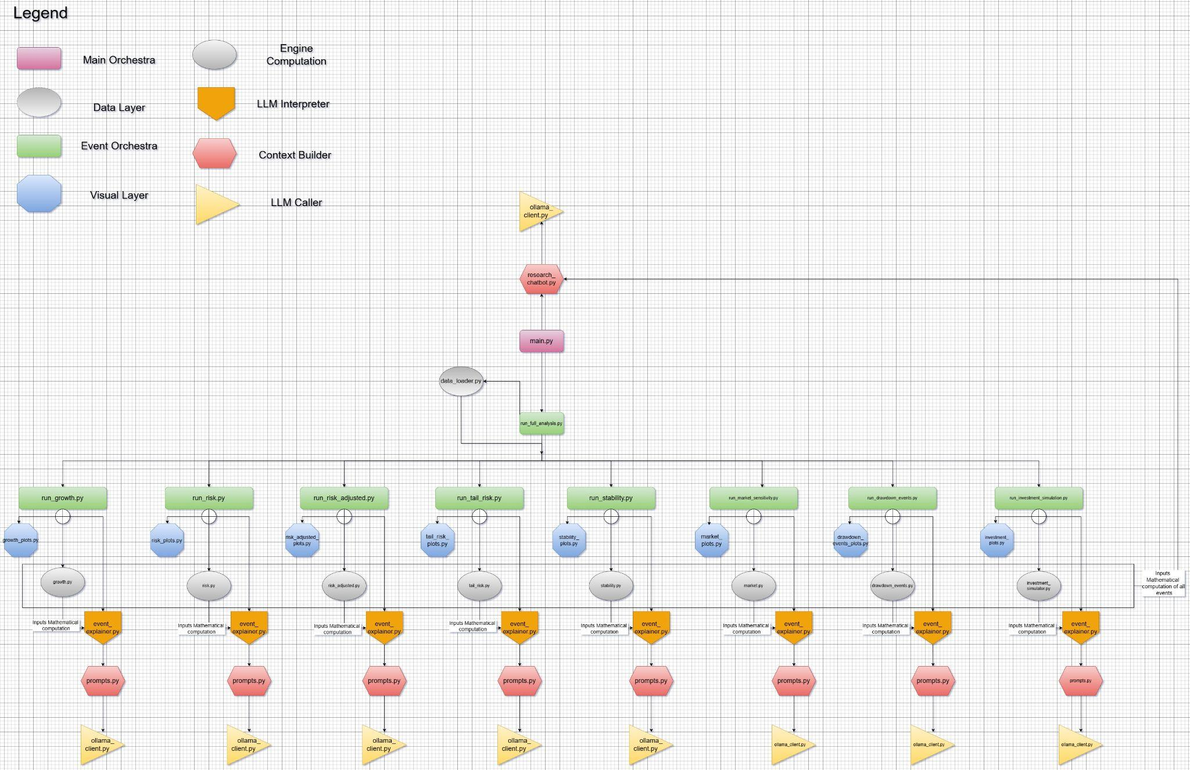

Link: https://drive.google.com/file/d/1KijHrFC6SHCRZxPAEBUKO54iFtnGbY7o/view?usp=sharing

E. Folder Structure:
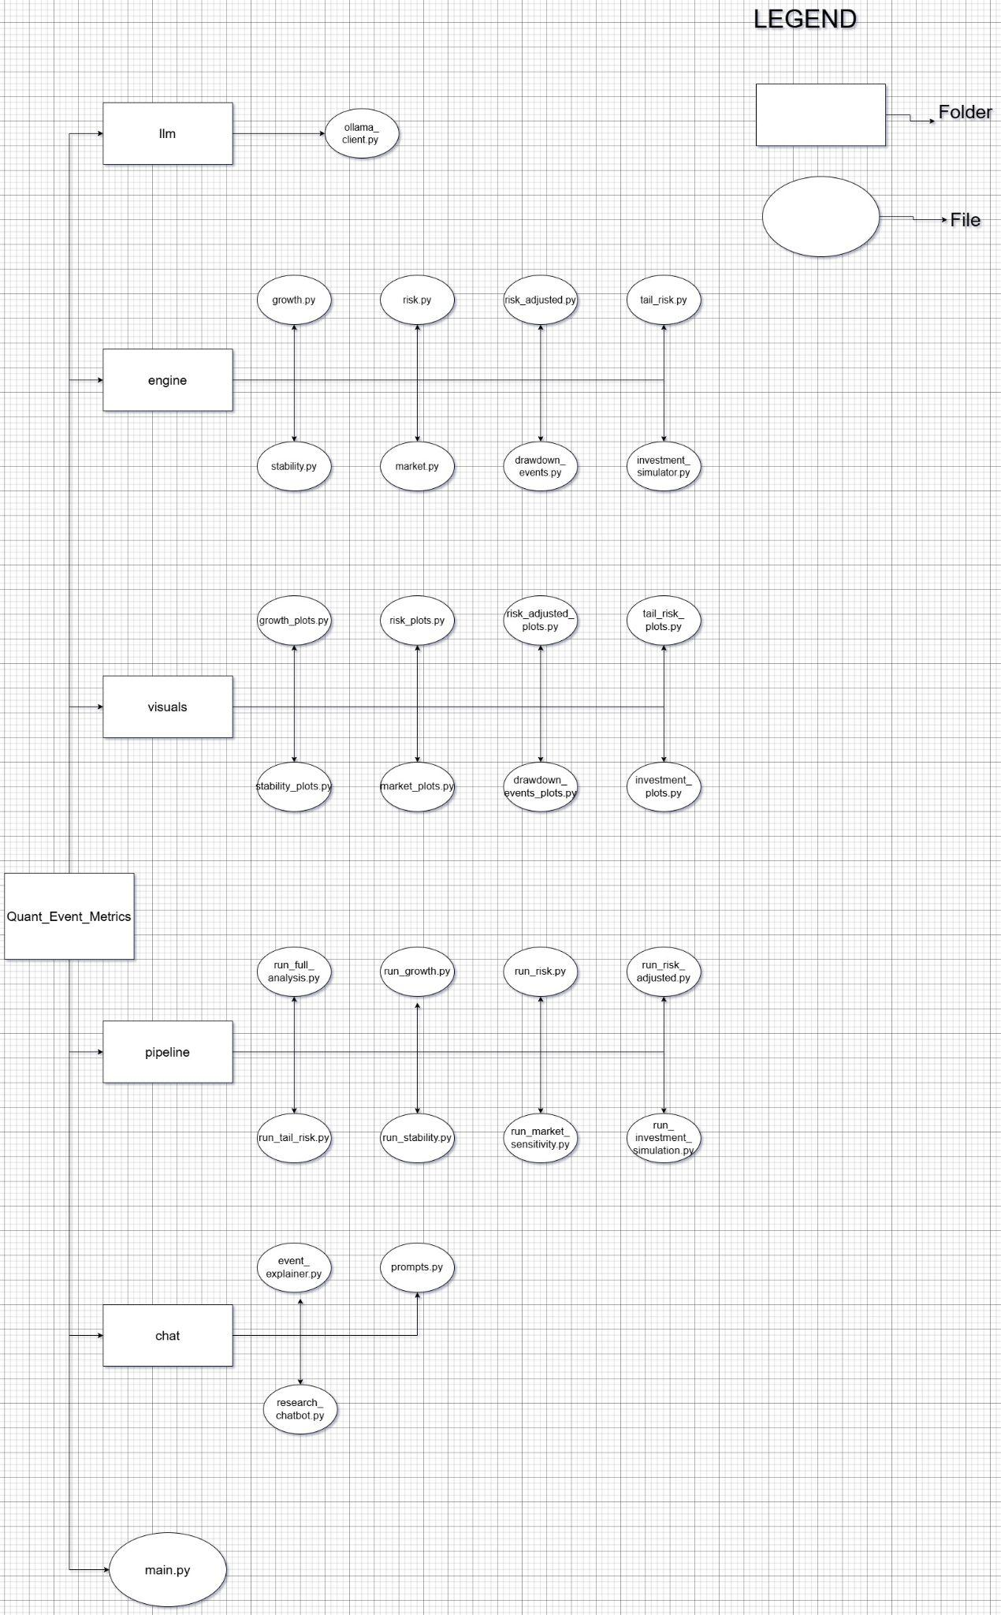
Link:
https://drive.google.com/file/d/1UHh35z6lRQXnoyDnUeoVb9CNQY0ZZ7PQ/view?usp=sharing

F. Detailed Layer Designed:

1. Main Orchestra:
File: main.py
- This layer defines the main.py code which integrates the Global Chatbot and the Pipeline (run_full_analysis.py) that is responsible for the functioning of Event Orchestra.
- This code is also the entry point for data analysis by taking in the ticker (stock’s name) along with the starting and the end timelines.

2. Data Layer:
File: engine/data_loader.py
- This layer extracts the ‘Close’ returns as data from yfinance library and then saves it by using timestamps as index.
- It then preprocesses the data by removing any empty points and then converts this 2D dataframe into a series.

3.Event Orchestra:
Files:
Pipelines Integrator: pipeline/run_full_analysis.py
Individual Pipelines: pipeline/run_growth.py , pipeline/run_risk.py ,
pipeline/run_risk_adjusted.py , pipeline/run_tail_risk.py ,
pipeline/run_stability.py , pipeline/run_market_sensitivity.py , pipeline/run_drawdown_events.py , pipeline/run_investment_simulation.py

- Pipeline Integrator: This file loads price data from engine/data_loader.py and then sends this data across individual pipelines for their event metric calculations. The mathematical computations from the individual pipelines are saved in this file and are formatted into a structured format, so that it can act as a knowledge for the Global chatbot to refer to.

- Individual Pipelines: There are 8 Individual pipelines and each of them handles 3 metrics - Mathematical Computations, Visual Representations and LLM interpretations. Each individual pipeline is specific to the events they handle in order to avoid any calculation crossovers between events. Pipelines are provided with logical triggers for the 3 metrics, suppose the user wants to try out only the visual representation of a particular event, they have the option to turn off all the other computations from all the other events except this one. This feature has widely helped me in testing out each individual metric across events. Once the output from the mathematical engine is computed, it is sent to the user for display and is also saved in a structured format to provide context for the LLM interpreter. Visual Representations are also shown by calling functions from the Visual Layer. The LLM interpreter now sends the context to the Context builder layer which helps in making personalised prompts after which it contacts the LLM caller layer for response.

4.Visual Layer:
Files:
visuals/growth_plots.py, visuals/risk_plots.py, visuals/risk_adjusted_plots.py, visuals/tail_risk_plots.py, visuals/stability_plots.py, visuals/market_plots.py, visuals/drawdown_events_plots.py, visuals/investment_plots.py

- There are 8 Visual files, each representing graphs specific to their events. This helps in understanding trends and time based patterns that are not captured by mathematical calculations.
- visuals/growth_plots.py - Graphs of Total returns vs Timeline, Cumulative returns vs Timeline
- visuals/risk_plots.py - Daily Log returns vs Timeline, Rolling Annualized Volatility, Drawdown percent vs Timeline
- visuals/risk_adjusted_plots.py - Rolling Sortino Ratio, Rolling Calmar Ratio, Summary bar graph(sharpe, sortino, calmar ratios)
- visuals/tail_risk_plots.py - Tail-Risk distribution (Returns distribution-bins, normal distribution, VaR and CVaR cutoffs)
- visuals/stability_plots.py - Rolling Sharpe Ratio, Drawdown Duration vs Timeline
- visuals/market_plots.py - Stock vs Market (scatterplot + linear regression line)
- visuals/drawdown_events_plots.py - bar graphs of (10 worst and most recent drawdowns + recoveries)
- visuals/investment_plots.py - portfolio value showing investment + extremes, Daily P&L Graph, Drawdowns with respect to investment.

5.Engine Computation:
Files:
engine/growth.py, engine/risk.py, engine/risk_adjusted.py,
engine/tail_risk.py, engine/stability.py, engine/market.py,
engine/drawdown_events.py, engine/investment_simulator.py

- This layer mainly focuses on statistical calculations of certain parameters that define the particular event. This forms the basis of the knowledge imparted in LLM interpreters and in the Global chatbot.
- engine/growth.py - Total returns, CAGR
- engine/risk.py - Annualized volatility, Downside volatility, Max drawdown
- engine/risk_adjusted.py - Sharpe ratio, Sortino ratio, Calmar ratio
- engine/tail_risk.py - Skewness, Excess kurtosis, VaR, CVaR
- engine/stability.py - Rolling Sharpe (min, max, mean), Max Drawdown duration, Recovery Time
- engine/market.py - Alpha, Beta, R² calculations from CAPM regression model
- engine/drawdown_events.py - Tabulated values showing worst drawdowns and longest recoveries, along with most recent drawdowns with recent recoveries.
- engine/investment_simulator.py - Given the initial investment value, it provides the final returns, max, min investment value reached over the timeline, max daily gain, loss incurred over the timeline.

6.LLM interpreter:
File: chat/event_explainer.py
- This layer is responsible for providing explanations and interpretations of the parameters and their outputs derived from the Engine Computation layer. The layer provides data from the Engine Computation to the Context builder which returns event specific prompts. This prompt is later sent to the LLM caller layer which provides the response interpreting the parameters.
- This layer acts independently for each pipeline, it does not send all the events data simultaneously but instead sends each event’s data separately as per the requirement.

7.Context Builder:
Files: For LLM interpreter: chat/prompts.py
For Global chatbot: chat/research_chatbot.py

- For LLM interpreter: Here each event is given a personalised prompt and in general the LLM is guided to explain:
1.Metric Interpretation (explains each parameter and what its values indicate)
2.Investor’s Experience (describes what holding this stock during this period would have felt like: volatility, emotional stress)
3.Contextual and scenario based insights (uses the general market knowledge, explains the plausible reasons why these results occurred)

- For Global chatbot: Here the knowledge and the user’s question is sent to the LLM caller layer, this is where it differentiates from the LLM interpreter since it allows for the user queries to be answered. The knowledge here is sent as a whole from all the events and this acts as a reference material for the LLM to look upon. In case the query asked is beyond the scope of knowledge then the LLM has the authority to use its own thinking and respond to the query without hallucinating.

8.LLM caller:
File: llm/ollama_client.py
- Ollama is an open source tool that allows us to run LLMs locally, they have a wide range of LLM models that are available to use for free.The Ollama model used for this project is phi3:mini, this model is lightweight and can even run on systems having 8GB RAM.
- The link with the LLM model occurs when the HTTP requests for a connection with the localhost port running the Ollama server.This connection creates a TCP socket from which the Ollama server receives the POST request containing the prompt and the model to be used.
- Ollama checks if the model is loaded and sends the prompt to the model. The model now computes the response and sends it back to the server.
- Hence in the file (llm/ollama_client.py) the code connects to the Ollama server using its local hosting port and the API endpoint. The prompt and the response both traverse in json format through the network.

G. Sample Code Run of One Event Metrics:
Event: Tail Risk

Engine Computation:
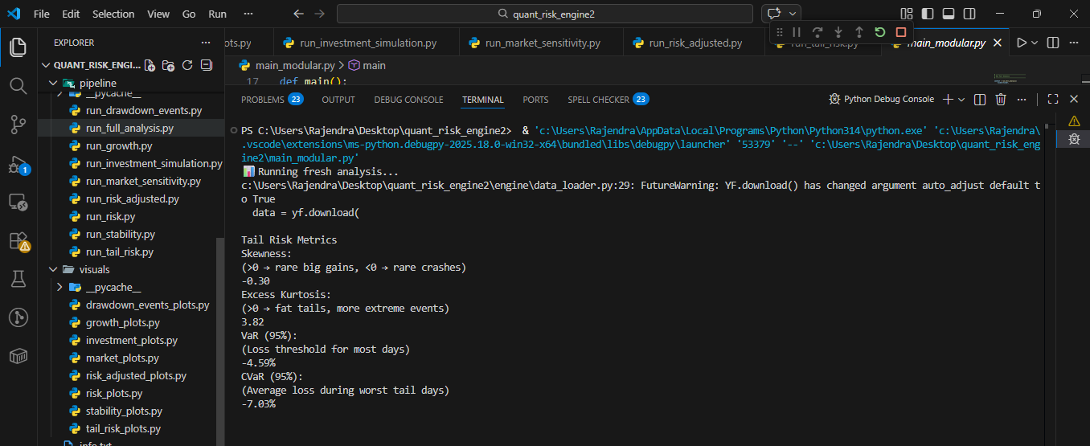

Visual Layer:
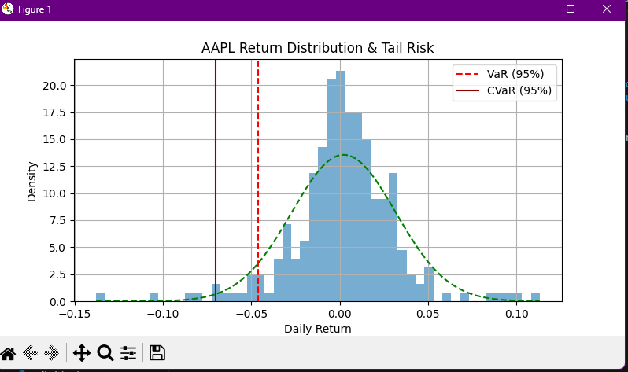

LLM interpreter:
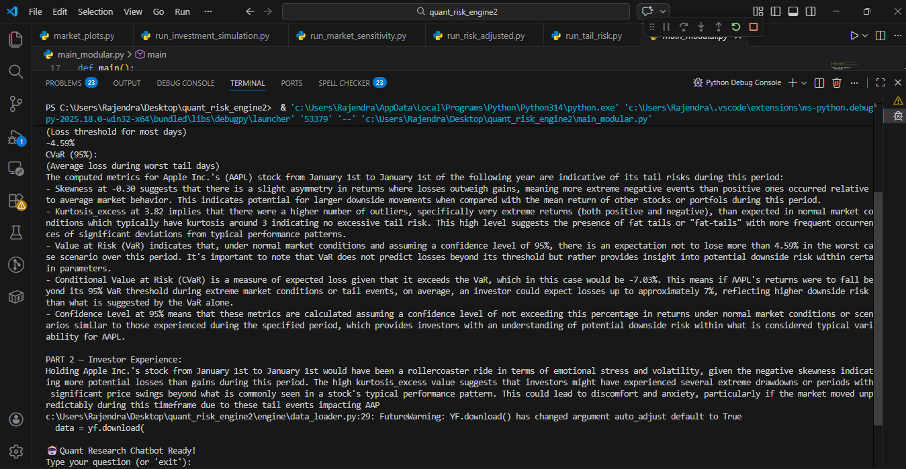
:

Global Chatbot:
